## MsToal Science Introduction to the Earth Name

Orbit of the Earth:

**Average distance from the sun**

**__________________ miles or**

**____ AU**

**Average Orbital Velocity=  
____________________**

January ____

June ____

**Period of   
revolution=**

**________days**

The Seasons  
9) caused by the _____________________

* *NOT* due to changes in the distance of the Earth from the Sun!!!

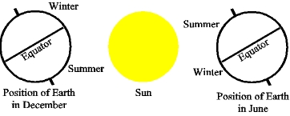

1) Earth’s Surface

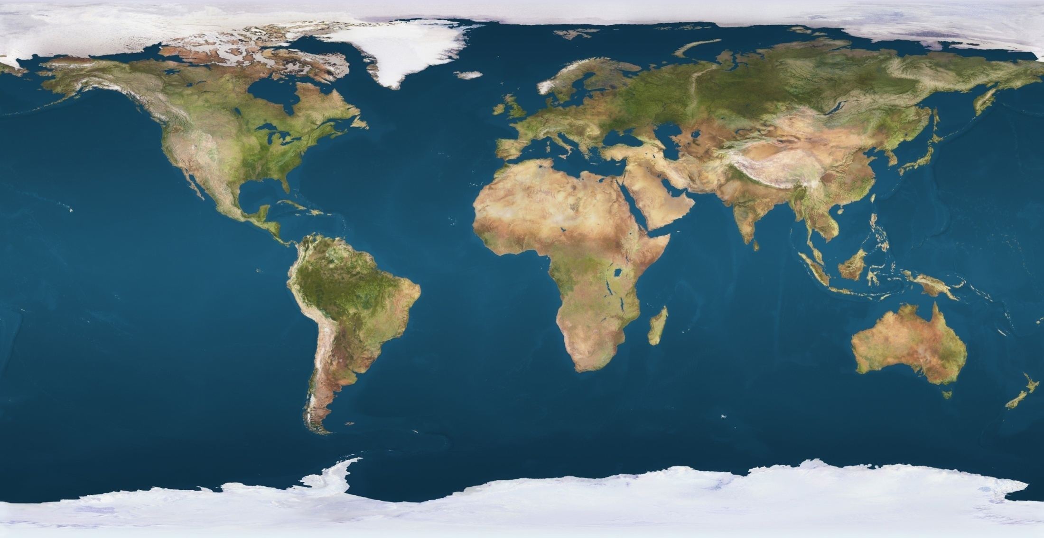

_______%______________________

_______%______________________

Earth’s Data

2) Age= _____________ years old  
3) Diameter: ___________  
4) Temperature Range:_______________  
5) Gravity=_____________

The tilt of the Earth’s axis affects:  
 10a) __________________________ (Insolation)  
 how directly the rays of the sun hit the ground

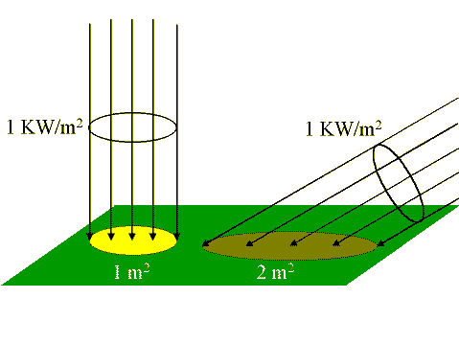

6)Average Distance

●______

●___ million miles

●__________ from  
 ________ __ _____

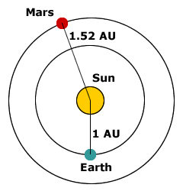

**Motions of the Earth**  
7)_______________

* + daily motion
  + it takes _________________   
    for the earth to spin around ________________

**8) ______________________________**

* + yearly motion
  + It takes ________________for the earth to go around ______________________.   
    Draw Figure 3 Page 465

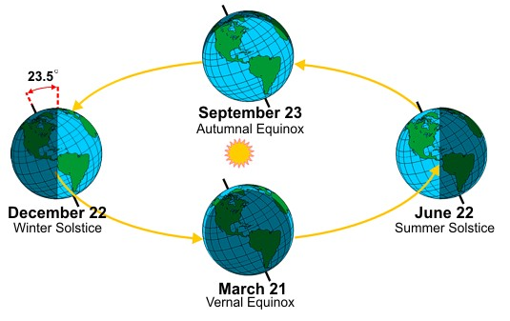

10b)The Tilt also affects: ____________ ___________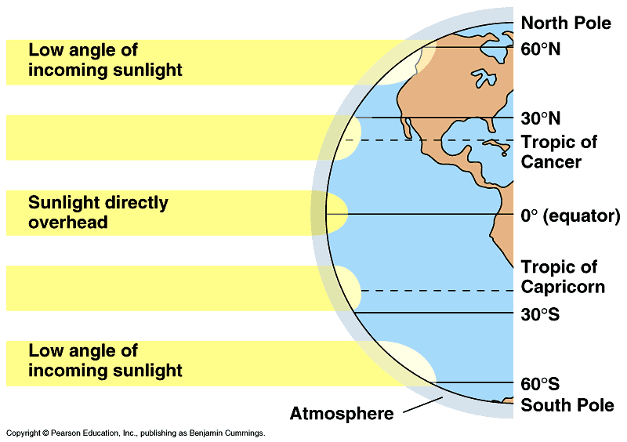_______________

On page _______ in your blue textbook, there is a diagram of earth as it revolves the sun and it illustrates the tilt of the earth during its four seasons. Draw that diagram on the space below or on a separate piece of paper if you don't have enough room. Yes, label everything like the book and add color.

13) Equinoxes:Day = Night equal length

**_____________ _______________**

**Insolation = __________ Insolation = __________**

**Length of day = ________ Length of day = _______**

**_________ in the __________ in the  
Northern Hemispher**e **Northern Hemisphere**

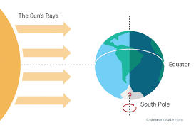

**12) Winter in Livermore**

**___________**(Winter Solstice)**_______ insolation** for us

**Length of the Day: _________**

**__________________ hemisphere** tilted towards the Sun

Distance from the Sun: 147 Million km ____________

**Coldest Month: _______________**

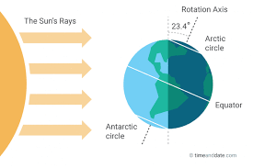**-**

**11)Summer in Livermore**

**_________**(Summer Solstice) **_______insolation** for us

**Length of the Day:_______**

**_________________ hemisphere** tilted towards the Sun

Distance from the Sun: 152 Million km ________

**Hottest Month : _________**

